SULTAN
56189
CH. MUBASHIR
56892
WAQAR ALI
57516
BS/DS-4_1
Project Title: To-Do List Web Application

- Project Overview
The To-Do List Web Application is a lightweight and user-friendly task management system designed to help users keep track of their daily responsibilities. The application is built using a, an SQLite database, and a front-end designed with HTML and CSS. It enables users to register, log in securely, and manage their personal tasks, including creating, editing, deleting, and marking them as complete. The project adopts the Incremental Process Model to deliver functionality in structured phases, ensuring flexibility, early delivery, and continuous user feedback.
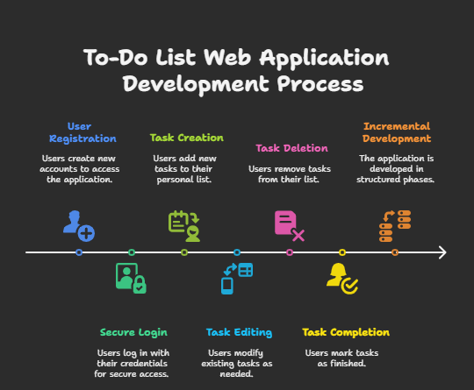

- Abstract
Managing tasks effectively is critical for personal productivity and organizational efficiency. The To-Do List Web Application provides a digital solution to manage tasks, deadlines, and priorities. By implementing a minimal yet powerful set of features such as user authentication, CRUD operations for tasks, and prioritization, users can stay organized and improve their productivity. The use of the Incremental Process Model allows for staged delivery and early detection of errors, making the development process more reliable and maintainable.

- Objectives
- User Authentication: Ensure secure access using encrypted login credentials.
- Task CRUD Operations: Enable users to Create, Read, Update, and Delete tasks easily.
- Task Prioritization: Allow categorization of tasks into Low, Medium, and High priorities.
- Task Filtering: Help users sort and view tasks based on status or priority.
- Usability: Provide an intuitive interface that enhances user experience.

- Key Features
- Secure Login and Registration: Users can securely register and log into their accounts.
- Task Management Interface: A clear UI to manage tasks with forms for editing and creating.
- Priority Levels: Visual indicators (color codes or badges) for task priority.
- Completion Status: Tasks can be toggled between complete and incomplete.
- Responsive Design: Interface adapts for mobile and desktop devices.

- Task Management
Task management is the application's core functionality. Users interact with tasks by creating, updating, and organizing them. Each task includes metadata such as a title, due date, description, priority, and completion status. The system uses these attributes to filter and sort tasks, enabling better user productivity.

- Incremental Process Model: Detailed Explanation
The Incremental Process Model is a structured approach to software development in which the system is built gradually by adding functional components in successive increments. Each increment is treated as a mini-project with its own planning, development, and testing phases. This method ensures that usable software is available early in the process and can be improved based on user feedback.
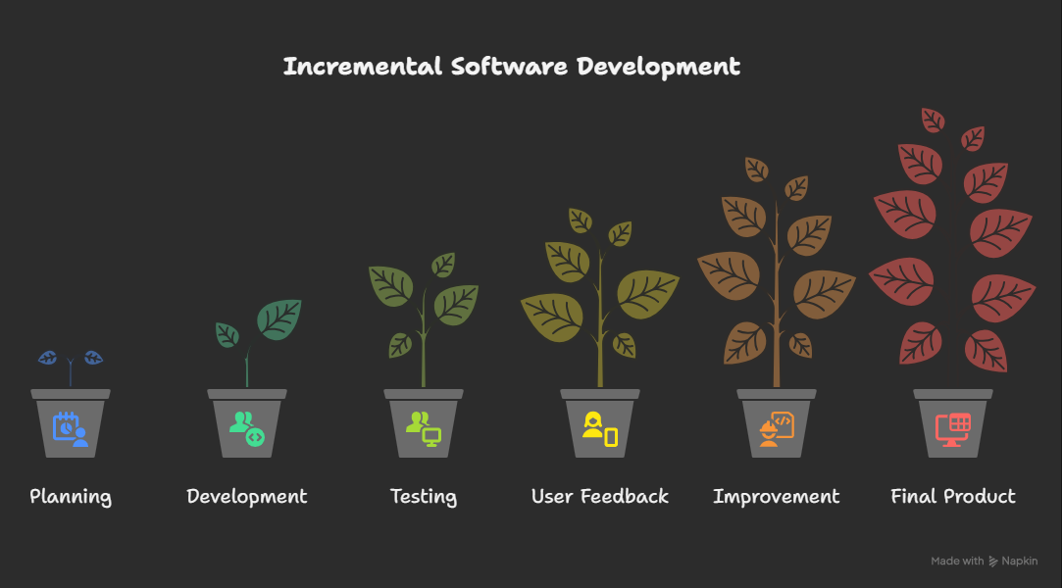

Why Choose the Incremental Model?

1. Modular Development
- The project is divided into smaller, manageable components or increments.
- Each increment adds specific functionality, allowing for focused development and testing.
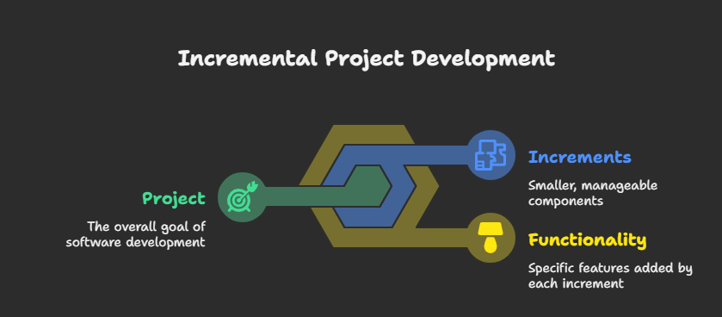

2. Early Delivery of Functional Software
- A basic version of the application can be delivered early in the development cycle.
- Users can begin interacting with the software sooner, providing valuable feedback.
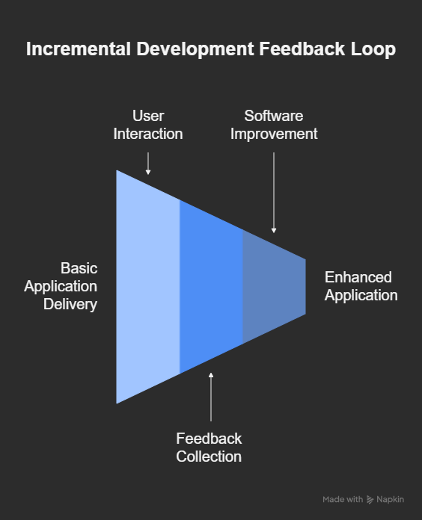

3. Flexibility in Requirements
- Changes or new requirements can be incorporated in subsequent increments.
- This adaptability is crucial for projects where user needs may evolve.
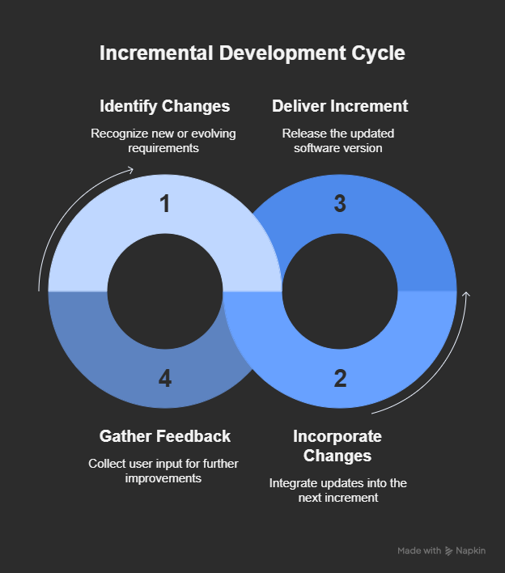

4. Risk Management
- By developing in increments, potential risks can be identified and addressed early.
- Issues in one increment can be resolved without impacting the entire system.
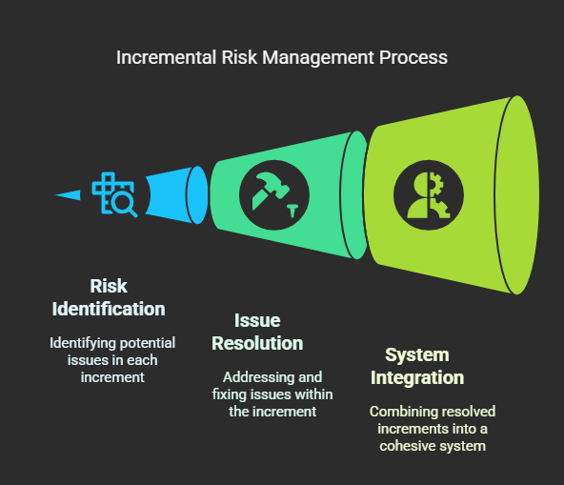

5. Efficient Testing and Debugging
- Smaller codebases in each increment simplify testing processes.
- Errors can be detected and fixed more easily within individual increments.
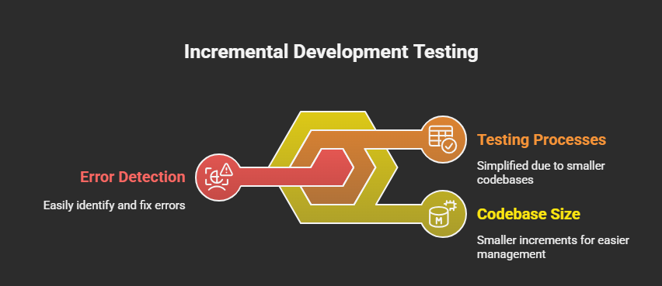

Detailed Steps:
- Requirement Analysis:
  - For each increment, the team identifies the specific set of features or enhancements to be delivered.
  - This phase involves meeting with stakeholders, understanding their expectations, and documenting both functional and non-functional requirements specific to the increment.
- Design:
  - After requirements are finalized, the system architecture and UI for the new increment are designed.
  - This includes creating detailed flowcharts, entity-relationship diagrams (ERDs), and screen wireframes.
  - The design integrates seamlessly with the existing system, ensuring that new components fit well into the overall architecture.
- Implementation:
  - Developers write the actual code for the features defined in the increment.
  - The codebase is modularized to ensure ease of integration and future scalability.
  - Proper coding standards, commenting, and version control are followed.
- Testing:
  - The increment undergoes unit testing, integration testing, and user acceptance testing.
  - Test cases are created for each new functionality to verify correctness, usability, and performance.
  - Bugs or inconsistencies are documented and resolved before deployment.
- Integration:
  - Once tested, the new increment is merged with the existing system.
  - This may involve database schema updates, updating configuration files, and ensuring compatibility.
  - Regression testing is performed to ensure that existing features continue to work.
- Evaluation:
  - The newly integrated system is reviewed by developers, testers, and stakeholders.
  - Feedback is gathered to identify areas of improvement and new requirements for the next increment.
  - Lessons learned are documented for better planning in future cycles.
This cycle is repeated until the full functionality envisioned at the project's start has been implemented. The iterative nature of this model ensures continuous improvement, risk mitigation, and adaptability to evolving user needs.
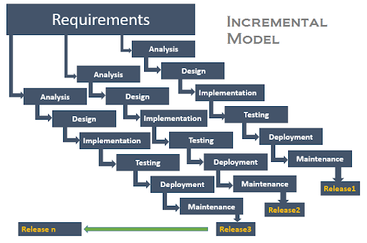

- Pros of the Incremental Model
- Early Delivery: Initial functionality is available to users early in the lifecycle.
- Flexibility: Adapts to changing user requirements during development.
- Risk Mitigation: Each increment reduces risk by focusing on a small set of features.
- User Feedback: Users can evaluate and suggest improvements at each step.
- Focused Testing: Smaller, manageable chunks are easier to test and debug.

- Cons of the Incremental Model
- Integration Challenges: Combining increments can result in conflicts or performance issues.
- Detailed Planning Required: Requires disciplined planning for each phase.
- Resource Intensive: May require continuous user interaction and developer availability.
- Incomplete Early Stages: Early versions might lack key features and appear unfinished.
- Increased Documentation: Each increment requires its own documentation and review.

- Use Case: Task Creation
Actors: Registered User Preconditions: User is authenticated Steps:
- User clicks "Add Task"
- Enters task details: title, description, due date, priority
- Clicks "Save"
- Task is added to the database and displayed Postconditions: New task is visible and modifiable

- Functional Requirements
- User Registration: Users can register with a unique username and password.
- User Login: Registered users can log in to the system.
- Task Creation: Users can create new tasks.
- Task Editing: Users can edit existing tasks.
- Task Deletion: Users can delete tasks.
- Task Viewing: Users can view a list of their tasks.
- Task Filtering: Users can filter tasks based on status or priority.
- Task Prioritization: Users can set priority levels for tasks.
- Task Completion: Users can mark tasks as completed.
- User Logout: Users can log out of the system.

- Non-Functional Requirements
- Performance: The system should respond to user actions within 2 seconds.
- Scalability: The system should handle up to 1000 concurrent users.
- Security: User data should be encrypted and securely stored.
- Usability: The interface should be intuitive and easy to navigate.
- Reliability: The system should have 99.9% uptime.
- Maintainability: Code should be modular and well-documented.
- Portability: The application should run on major web browsers.
- Availability: The system should be available 24/7.
- Data Integrity: Data should be consistent and accurate.
- Compliance: The system should comply with relevant data protection regulations.

- Expected Outcomes
- A functioning prototype of the To-Do List Web Application
- Fully documented process adhering to software engineering principles
- A modular and scalable backend integrated with a responsive front end
- Insight into real-world application of Incremental Model

- Future Enhancements
- Integration with Google Calendar
- Email or push notifications for upcoming tasks
- Multi-user collaboration on shared tasks
- Progress analytics dashboards
- Full mobile app development using React Native or Flutter

14.ER Diagram Relationship:
1. users
Purpose: Stores information about users of the system.
- id: Unique user ID (Primary Key)
- name: Full name of the user
- email: Unique email address
- password_hash: Hashed password for secure login
- role_id: Foreign key linking to roles.id
- profile_image: URL/path to profile image (optional)
- is_verified: Indicates if the user is verified (email or 2FA)
- created_at: Timestamp when the account was created

2. roles
Purpose: Defines user roles in the system.
- id: Role ID (Primary Key)
- name: Role name (e.g., Admin, Manager, Employee)

3. projects
Purpose: Holds data about user-created projects.
- id: Project ID (Primary Key)
- name: Name of the project
- description: Description of the project
- deadline: Project deadline date
- created_by: Foreign key linking to users.id
- created_at: Timestamp of creation

4. tasks
Purpose: Stores all core task details.
- id: Task ID (Primary Key)
- title: Task title
- description: Detailed task information
- priority: Priority level (Low, Medium, High)
- status: Current status (To Do, In Progress, Completed)
- start_date: Task start date
- due_date: Task deadline
- progress: Task progress percentage (0–100)
- created_by: Foreign key linking to users.id
- project_id: Foreign key linking to projects.id
- created_at: Timestamp when the task was created

5. task_assignments
Purpose: Manages task-user assignments (many-to-many).
- id: Assignment ID (Primary Key)
- task_id: Foreign key to tasks.id
- user_id: Foreign key to users.id

6. subtasks
Purpose: Allows tasks to be broken into smaller units.
- id: Subtask ID (Primary Key)
- task_id: Foreign key to parent task in tasks
- title: Subtask title
- status: Subtask status (To Do, In Progress, Done)

7. task_comments
Purpose: Enables user collaboration via comments.
- id: Comment ID (Primary Key)
- task_id: Foreign key to tasks.id
- user_id: Foreign key to users.id
- comment: Text of the comment
- created_at: Timestamp of comment creation

8. task_files
Purpose: Stores file attachments linked to tasks.
- id: File ID (Primary Key)
- task_id: Foreign key to tasks.id
- file_url: File path or URL
- uploaded_by: Foreign key to users.id
- uploaded_at: Timestamp when uploaded

9. notifications
Purpose: Keeps track of alerts and reminders for users.
- id: Notification ID (Primary Key)
- user_id: Foreign key to recipient in users
- message: Notification content
- is_read: Whether the notification is read
- created_at: Timestamp of creation

10. task_tags
Purpose: Stores tags or categories for tasks.
- id: Tag ID (Primary Key)
- name: Name of the tag (e.g., Urgent, Bug)

11. task_tag_map
Purpose: Maps tasks to multiple tags (many-to-many).
- id: Mapping ID (Primary Key)
- task_id: Foreign key to tasks.id
- tag_id: Foreign key to task_tags.id

12. activity_logs
Purpose: Tracks user activity and task changes.
- id: Log ID (Primary Key)
- user_id: Foreign key to users.id
- task_id: Foreign key to tasks.id
- action: Description of the action performed
- timestamp: Time of the activity

ENTITY RELATIONSHIPS (ER) OVERVIEW
- Users → Roles: Many-to-One
- Users ↔ Tasks: Many-to-Many (task_assignments)
- Users → Projects: One-to-Many (created_by)
- Projects ↔ Tasks: One-to-Many
- Tasks → Subtasks: One-to-Many
- Tasks → Comments, Files, Tags: One-to-Many or Many-to-Many
- Tasks ↔ Tags: Many-to-Many (task_tag_map)
- Tasks → Notifications / Activity Logs: One-to-Many

ER Diagram (CREATED WITH DRAW.IO)
The ER (Entity-Relationship) Diagram maps the database structure of the system, showing tables like users, tasks, projects, and their relationships.
It helps visualize how data entities are linked, especially many-to-many relationships (e.g., task assignments and tags).
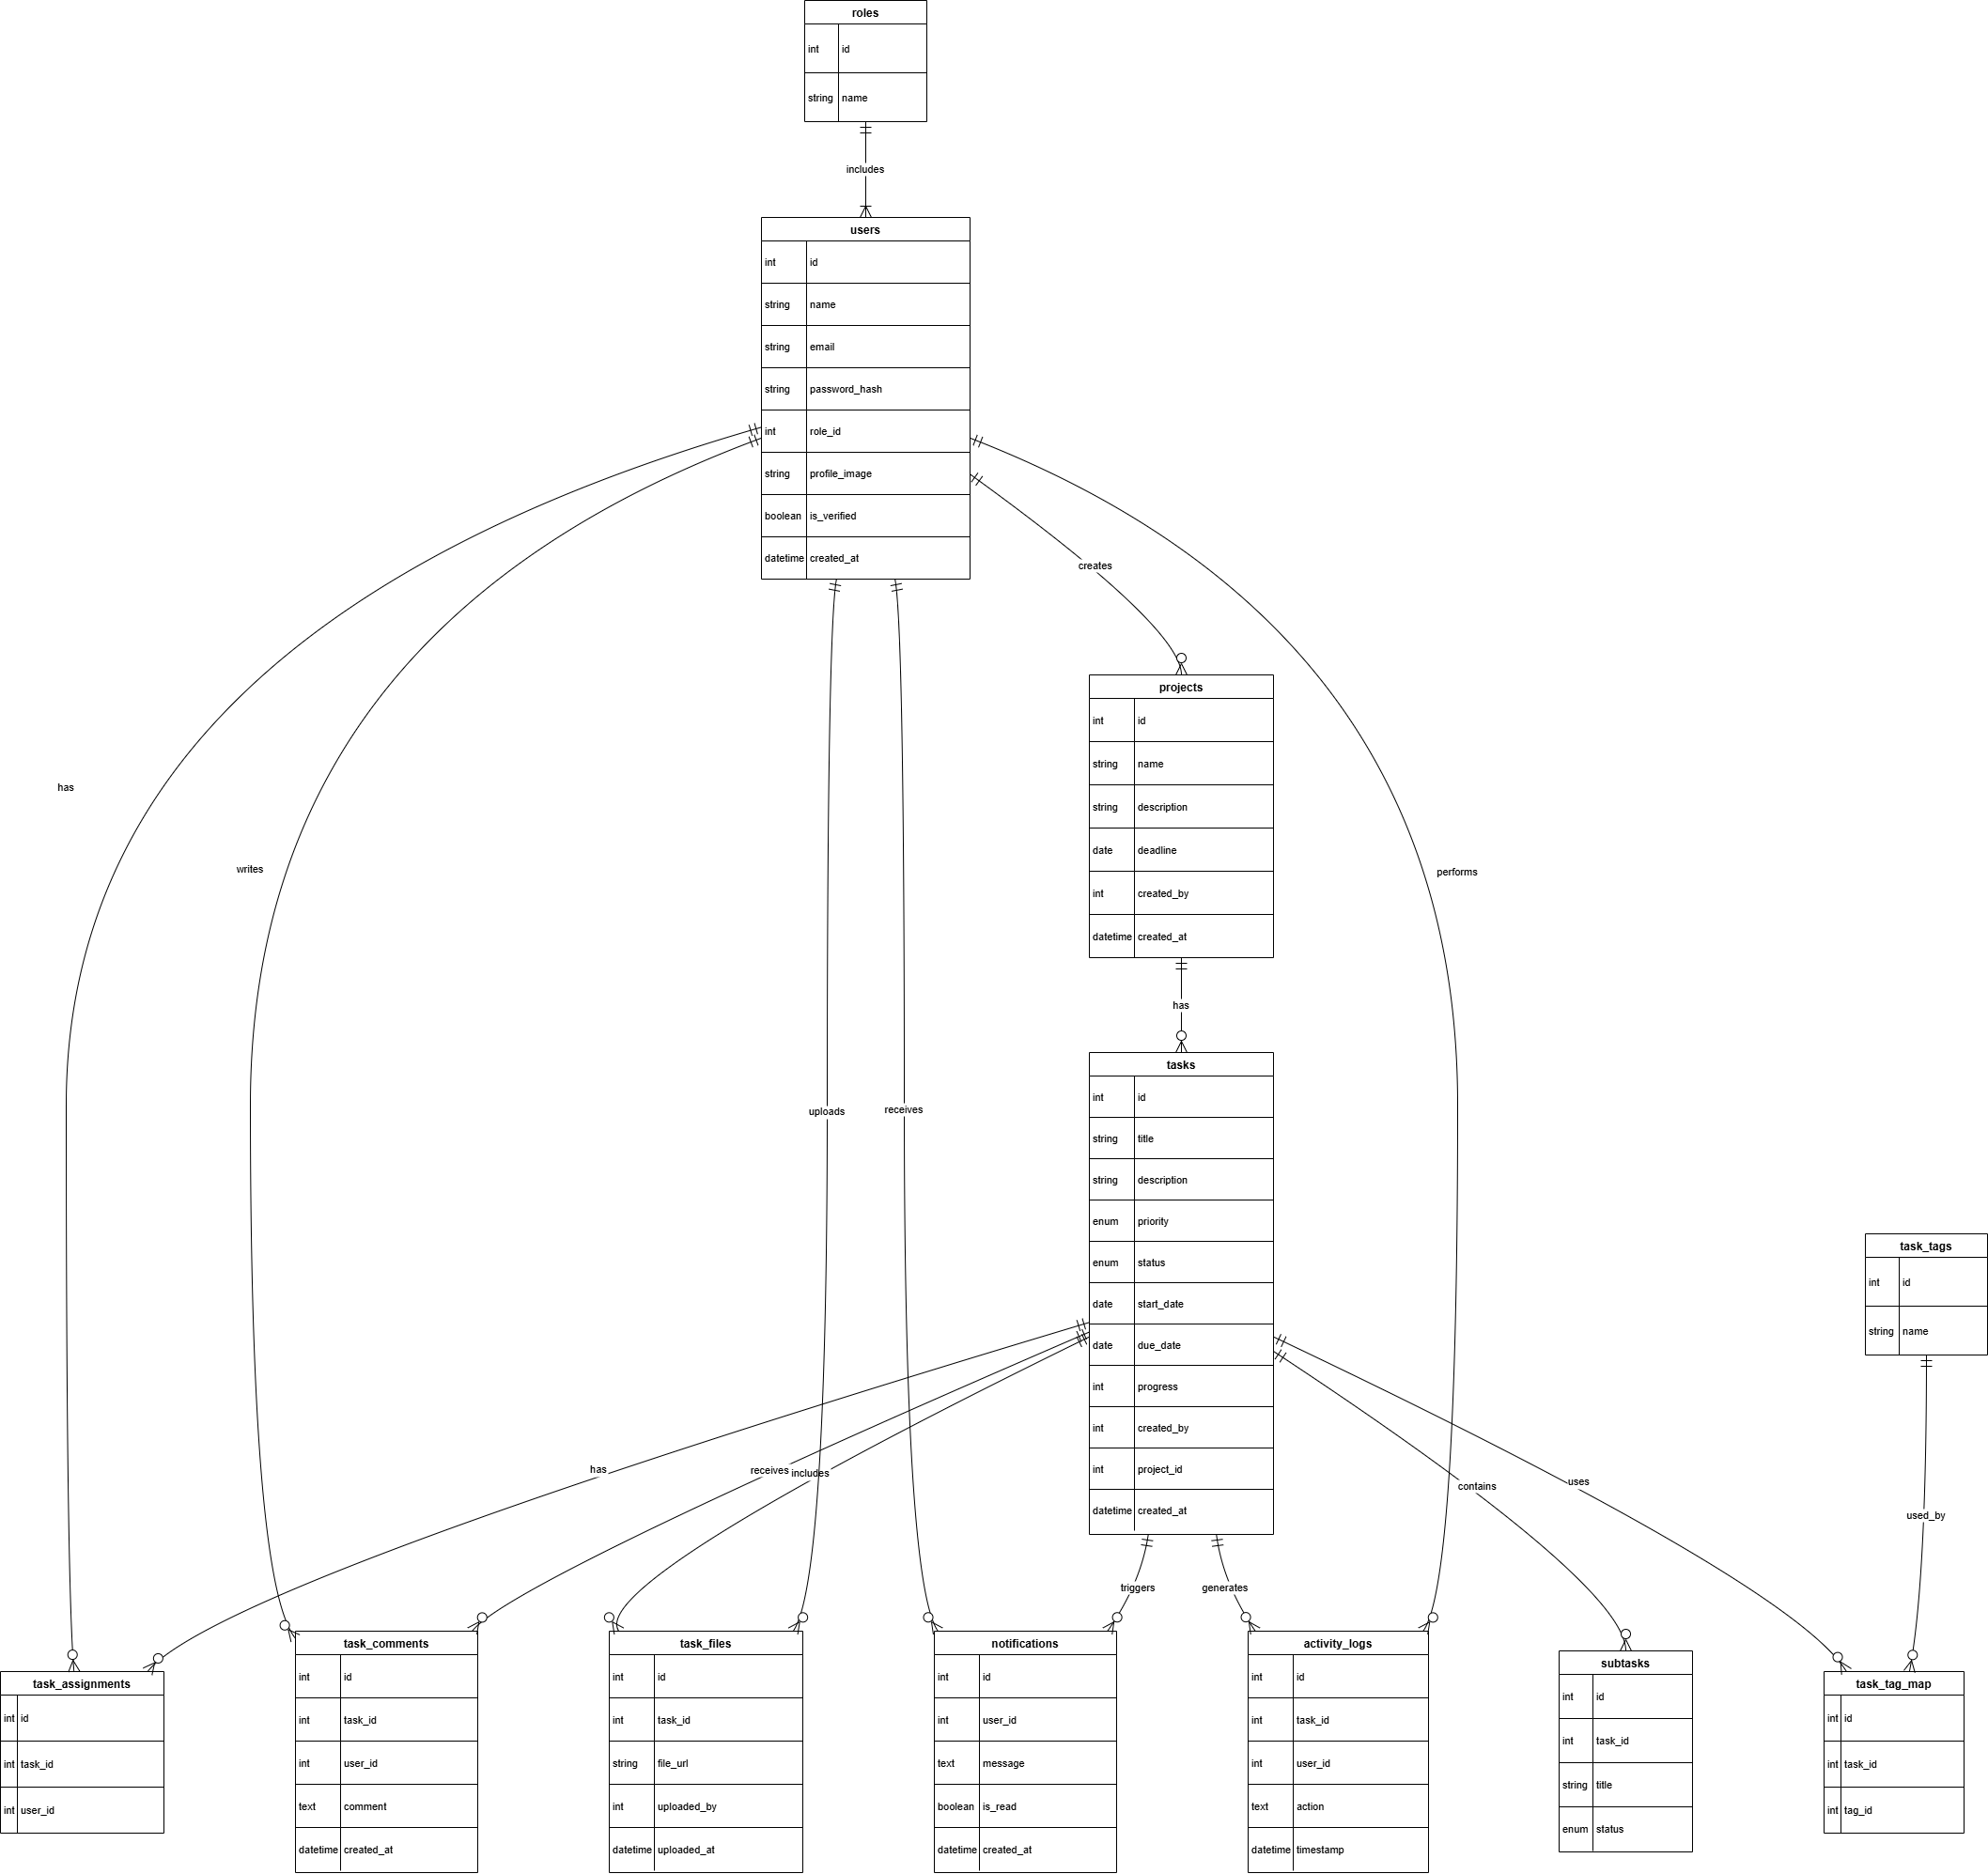
STATE DIAGRAM
The State Diagram illustrates how a task transitions through different statuses: Created → Assigned → In Progress → Completed → Archived.
It shows the task's lifecycle and how it responds to user actions or business logic.

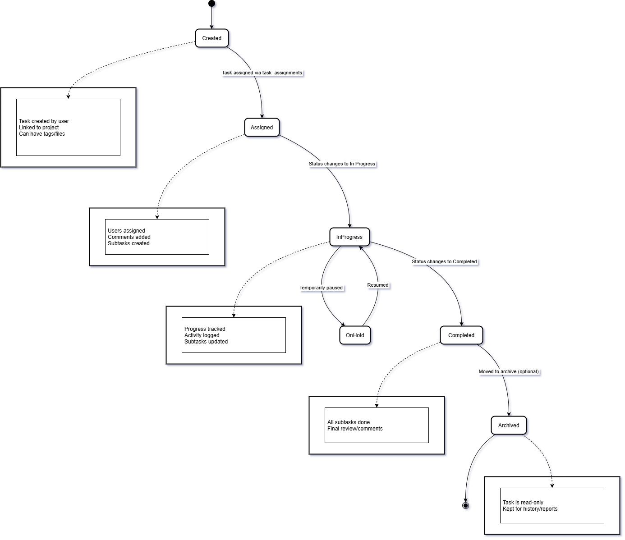
CLASS DIAGRAM
The Class Diagram represents the system in object-oriented terms, showingclasses like User, Task, and Project with their attributes and relationships.
It helps developers understand how backend classes or ORM models correspond to the database schema.

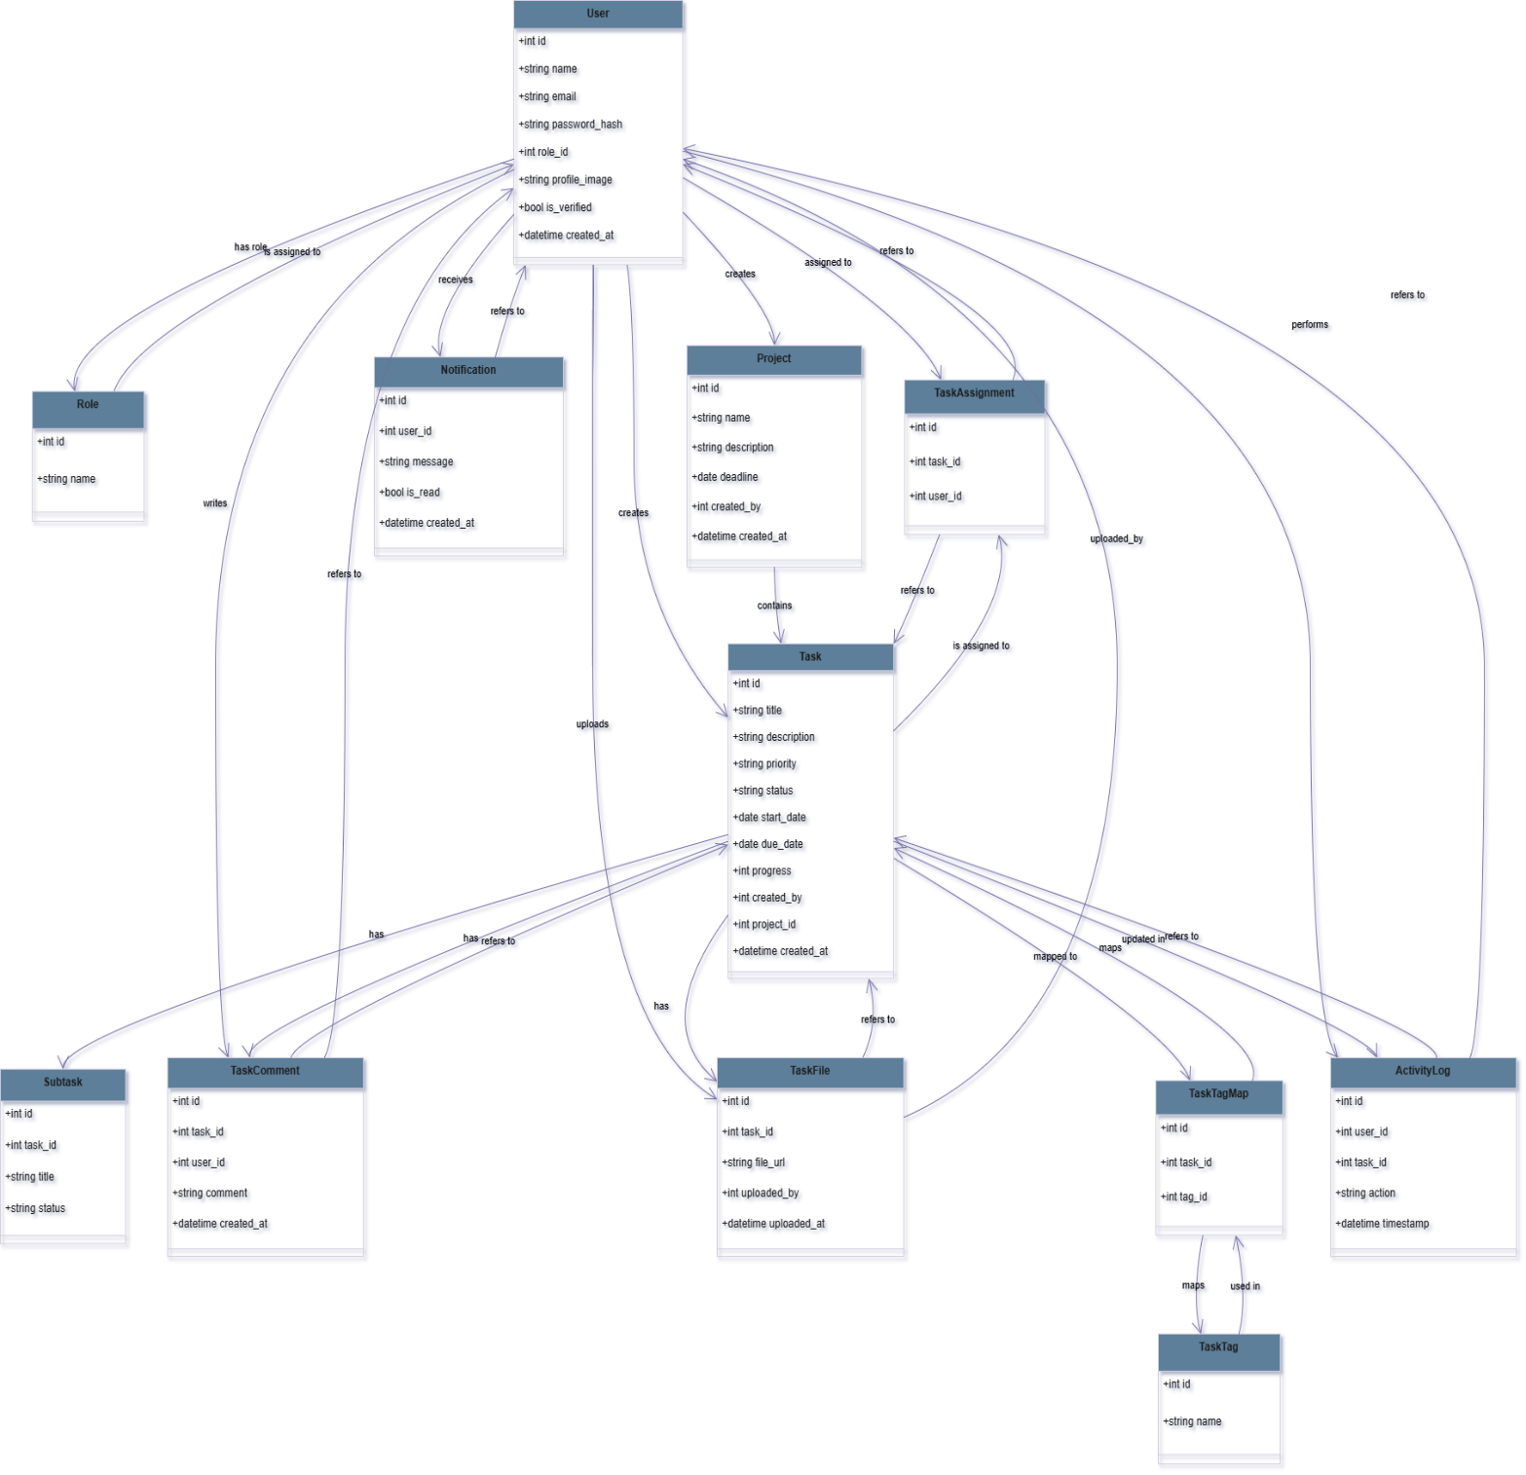
USE-CASE DIAGRAM
The use case diagram illustrates the interaction between different types of users (Admin, Manager, Employee) and the functionalities they can access in the Task Management System.
It provides a high-level overview of system capabilities from the user's perspective.
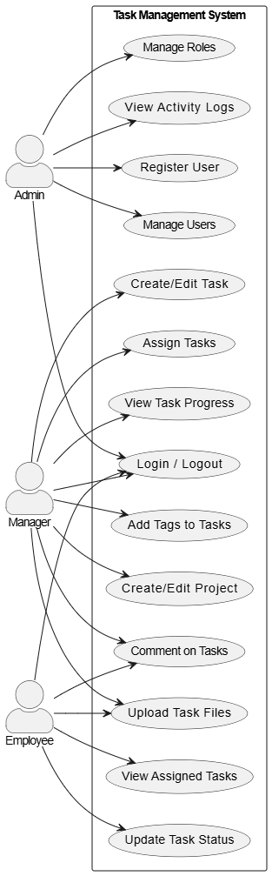
Sequence Diagram
This sequence diagram models the process of a Manager logging in, creating a task, and assigning it to an employee.
It demonstrates the step-by-step communication flow between the user interface, backend services, and database.

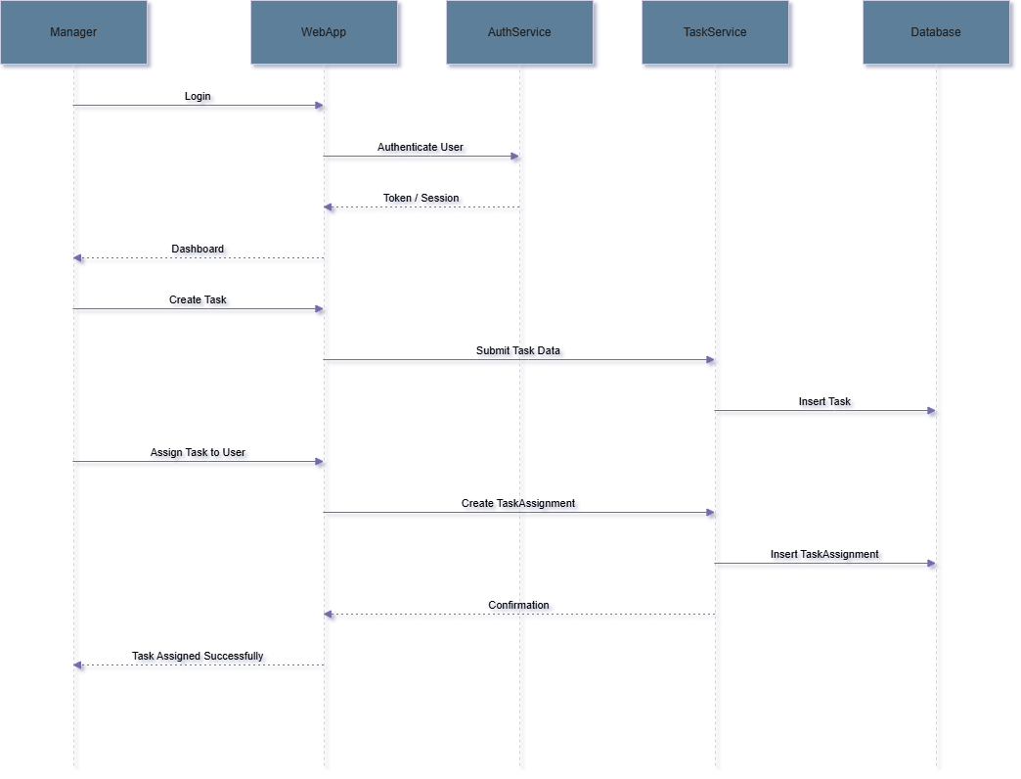
Component Diagram – System Architecture
The component diagram breaks down the architecture of the system into major components like the Auth Service, Task Service, and Notification Service.
It shows how the frontend communicates with backend components and how data is managed in multiple databases.

